Page-1 Overview

Reference Genome Resource Center

COVID-19 update:
As of 7/1/2020, along with the Rockefeller University’s Research Restart Plan, RGRC starts performing services under Phase-III Operations conditions.

The Reference Genome Resource Center (RGRC) at the Rockefeller University is a Resource Center specializing in high-molecular weight DNA and long-read genomic technologies.
The RGRC is one of the three main sequencing hubs of an international collaboration known as the Vertebrate Genomes Project (VGP). The VGP aims to produce near error-free, high-quality, phased, chromosome-level, annotated, reference genome assemblies of all extant 66,000 vertebrate species.
The RGRC experience and technical capability in long-reads are available to Rockefeller and external academic users.

We offer the following services:
- PacBio sequencing
- Bionano optical mapping

Contact us at vgl@rockefeller.edu for more information.

Page-2 Services

SERVICE | RU User | External Academic User
Pacbio Sequel II - 1 smrtcell
Pacbio genomic library (Hifi or CLR)
PacBio Iso-seq library
Bionano optical map (1 chip= 3 flowcells)

Page-3 Instruments

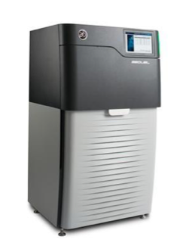
Pacific Biosciences Sequels

The RGRC has two PacBio Sequel 2 instruments and one PacBio Sequel 1 insturment. The PacBio Sequel is a third-generation sequencer based on PacBio-proven Single Molecule Real-Time (SMRT) technology to generate long reads with high consensus accuracy and uniform coverage.

Applications:
- Reference genome assembly (CLR or Hifi)
- Full length transcriptome sequencing (Iso-seq)
- Complex populations (e.g. bacteria, viruses)
- Targeted sequencing
- Epigenetic
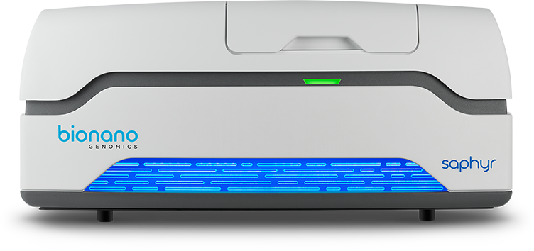

Bionano Genomics Saphyr

The Saphyr System is an optical mapping automated instrument. It allows imaging of high-molecular weight DNA migrating through NanoChannel arrays on the Saphyr Chip. This technology can be used to study of genomic structural variation sensitivity and scaffolding genomes.

Applications:
- Structural variation (large insertions/deletions, translocations, inversions)
- Reference genome assembly (scaffolding and assemblies correction)

Page-4 Contact us

The Reference Genome Resource Center
Weiss Building (7th floor)
The Rockefeller University
1230 York Avenue
New York, NY 10065
Phone: (212) 327-8216
Fax: (212) 327-8276
Email: vgl@rockefeller.edu

Meeting scheduling: https://Referencegenomeresourcecenter.youcanbook.me

Staff

Olivier Fedrigo, Ph.D. Director
Jacquelyn Mountcastle, M.P.H. Research Support Associate
Jennifer Balacco, MSc Research Support Associate

Page-5 Reference Genome Resource Center Phase II Operations

During phase III, the Reference Genome Resource Center will operate at lower capacity. Users should expect longer than normal turnaround time.
All service requests need to be made ahead of time through email (vgl@rockefeller.edu) and we will schedule a drop-off time. Please wear a mask and gloves when bringing your sample. Someone from the RGRC team will meet you at the main lab entrance of the lab (elevator lobby, Weiss 708). Users won’t be allowed in the RGRC lab and office spaces.

