Oral cancer surveillance study in Fanconi anemia patients

Cancer in Fanconi anemia
Fanconi anemia (FA) is a genetic disease caused by a failure of the body to repair damaged DNA (genetic material). This can lead to changes in the DNA, known as mutations. Due to these mutations, patients with FA have a high risk of cancers, especially a type of cancer known as squamous cell carcinoma (SCC). This cancer is 500-fold more common in FA patients than in the general population and appears at an earlier age in FA patients.

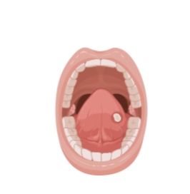
As most SCCs in FA patients occur in the mouth and are typically preceded by visible lesions, they can be detected early, at a stage in which it is localized and resectable. Therefore, it is very important that FA patients are examined frequently to detect oral lesions. If an oral lesion is suspected to be abnormal, the doctor must take a surgical biopsy for an accurate diagnosis. FA patients may have multiple lesions in their mouth. As these cannot all be surgically biopsied or removed, a new noninvasive method for cancer diagnosis is in development – a brush biopsy.


1/1/2023

Brush biopsy

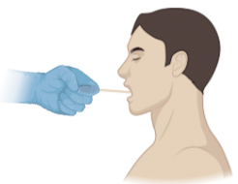
Brush biopsy allows for the easy, noninvasive collection of cells from the mouth, using a brush resembling a toothbrush, and can be used to sample multiple places in the mouth. The cells collected can be analyzed according to their appearance and for the presence of mutations. This will aid in diagnosis of precancerous or cancerous cells and guide the need for a surgical biopsy.

What is the purpose of our study?
From Biorender

The reason for doing this research is to find early changes in the mouth cell lining (mucosa) from patients with FA which would allow for early and noninvasive detection of a common cancer called squamous cell carcinoma.

Tamar Berger, MD
Principal Investigator
212-327-8862
tberger@rockefeller.edu
z

Who is eligible to participate?

We are looking to recruit patients with a diagnosis of Fanconi anemia above the age of 12 years, as well as adult healthy volunteers. You will be compensated for participating in the study.
Study Coordinator
212-327-8613
ylin@rockefeller.edu

What happens during the study?
Yu-Chien Lin
Study Coordinator
212-327-8613
ylin@rockefeller.edu

We will examine your mouth and record it using a camera. We will collect cells using a brush from multiple locations in the mouth, from normal-appearing areas in the mouth, and from abnormal looking areas (if any are present). We will look for changes in the cells’ appearance and genetic material (mutations). We will compare samples from FA patients to brush samples from healthy volunteers without FA.

In addition, a blood sample (about two tablespoons) will be taken for genetic testing and additional cancer marker screening. A skin biopsy will be performed in FA patients post bone marrow transplantation.

Using patient samples, we want to understand the disease so we can develop new preventive and treatment strategies as well as noninvasive early detection of cancer.

How do I get involved?

To get involved, you should contact our study coordinator. We will review the study with you in more detail, arrange for you to sign the necessary paperwork if you choose to participate and schedule an appointment at The Rockefeller University Hospital where we will collect your or your child’s samples.
Agata Smogorzewska, MD, PhD
Co-Principal Investigator
212-327-7850
asmogorzewska@rockefeller.edu

Contact Information:

Address:
1230 York Avenue, Box 182
New York, NY 10065
Fax: 212-327-8262

